# Contracting App User Manual

# Menu Tab

The top menu item (it will be displayed on every page)

1. Click on **ContractingApp /Home** to navigate to Home page
2. Click **Create Contract** to create a new contract between two Contractors
3. Click **Terminate Contract** to terminate an existing contract between two Contractors
4. Click **Contracting Chain** to find the shortest link between two Contractors

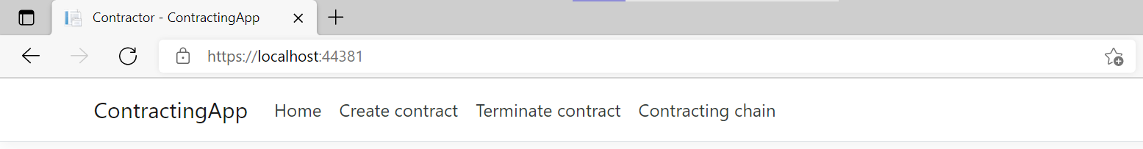

# Home Page

This is the landing page. The table displays all the contractors that are currently active.

Click on **Details** in hyperlink in the grid row to see the corresponding Contractor details

Click on **Add Contractor** hyperlink at the bottom of the page to Add a new contractor

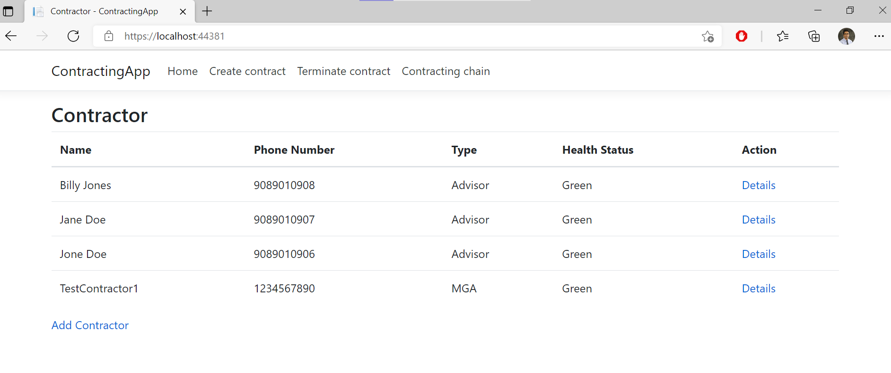

# Create Contract

Select Contractor 1 from drop down and Contractor 2 from drop down and click Submit button to create a new contract.

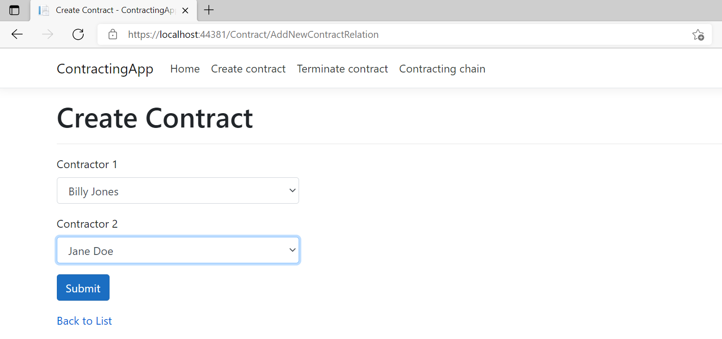

1. On click of submit system will check and create a new contract. If contract is created successfully an alert will be displayed

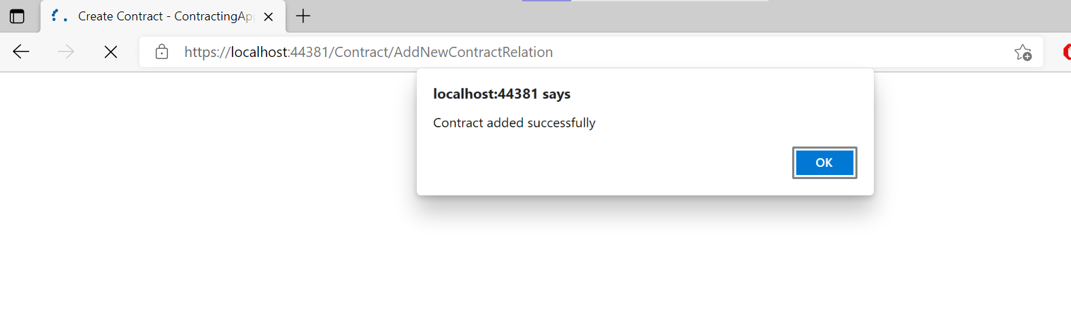

1. Duplicate Contracts cannot be created if the contractor 1 is already linked to contractor 2 an error message will be displayed

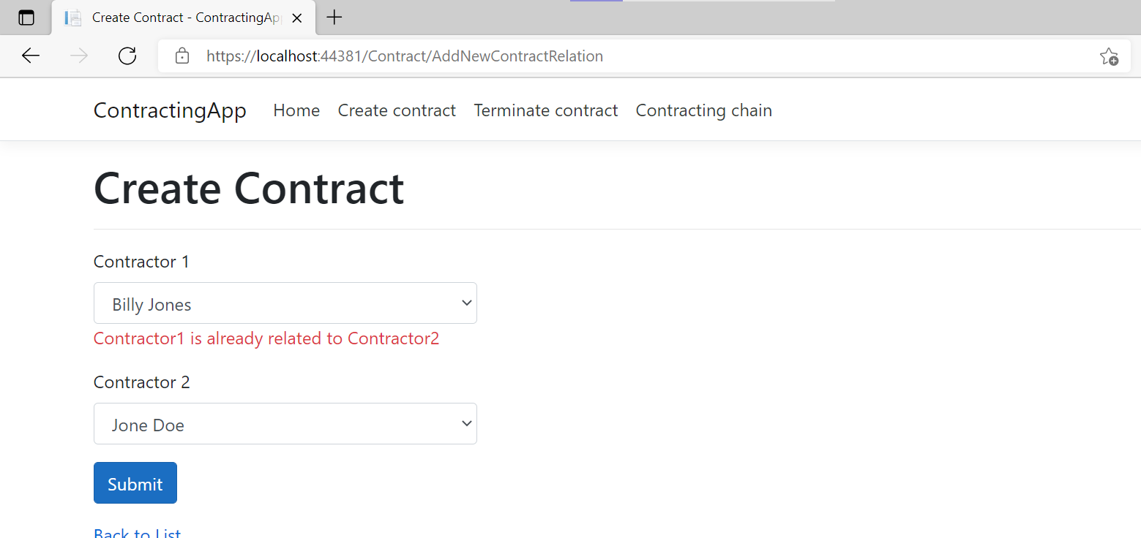

1. A contractor cannot be linked to itself. An error message will be displayed if such a scenario happens

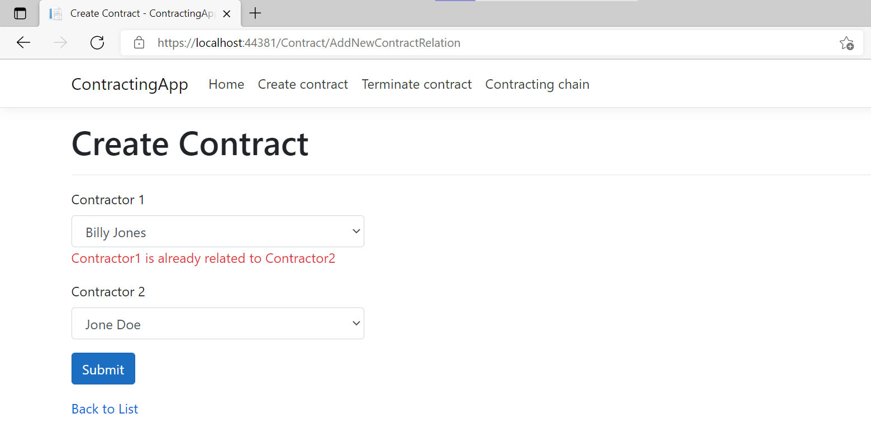

1. Contractors must be selected before Submit button is clicked. An error message will be displayed if it is not the case

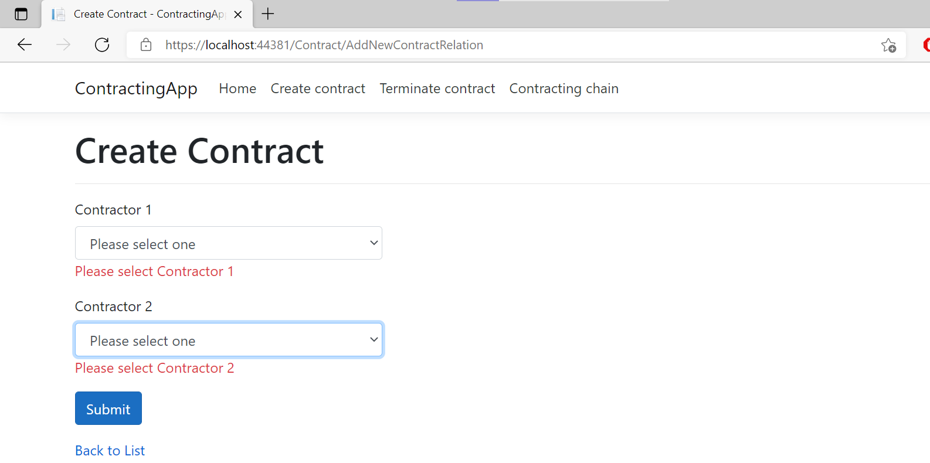

# Terminate Contract

1. Select a contractor from the drop down and click Fetch Related to get the list of related contractors

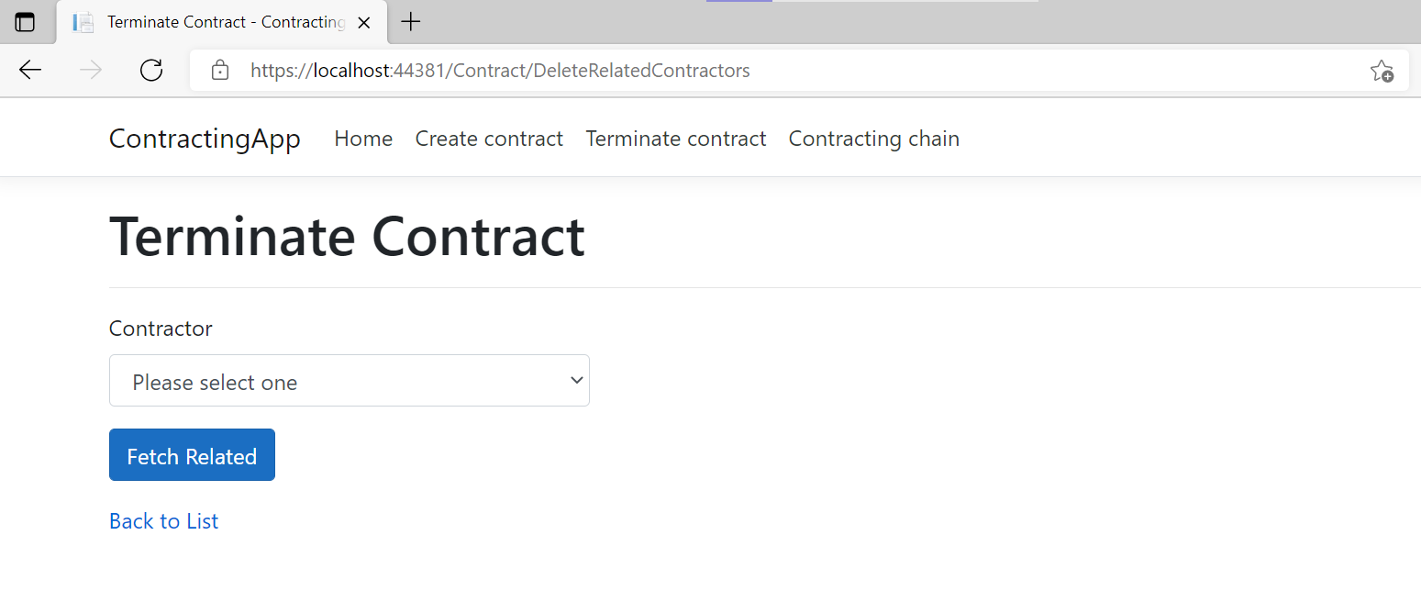

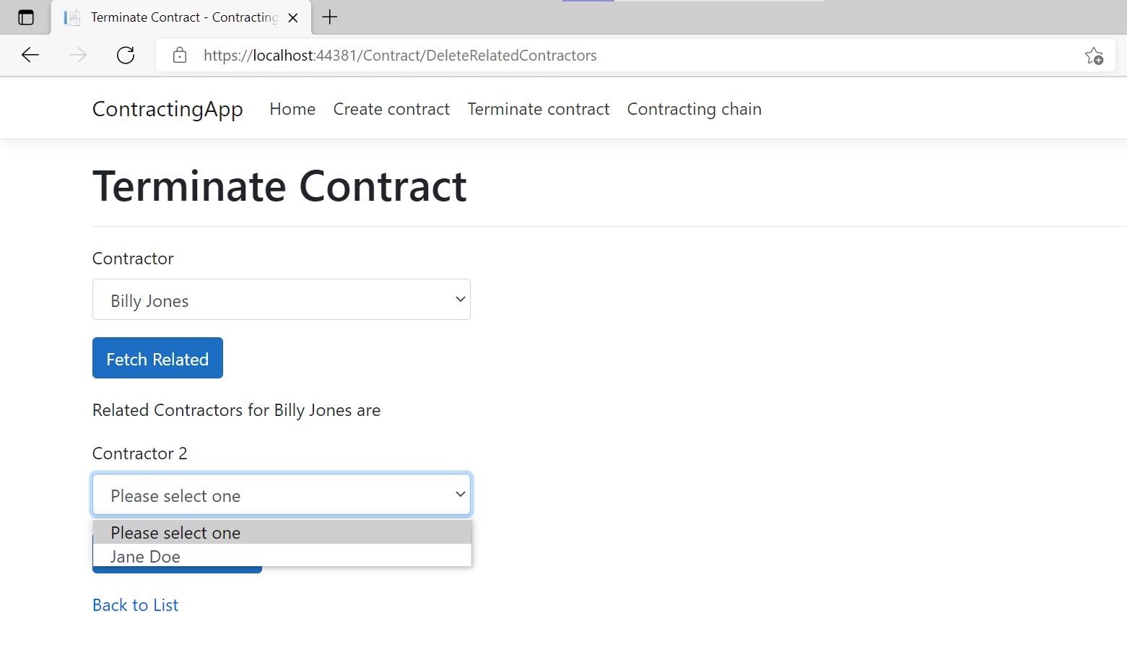

1. Select a related contractor and Click Terminate button to terminate contract. An alert will be displayed when the contract is terminated.

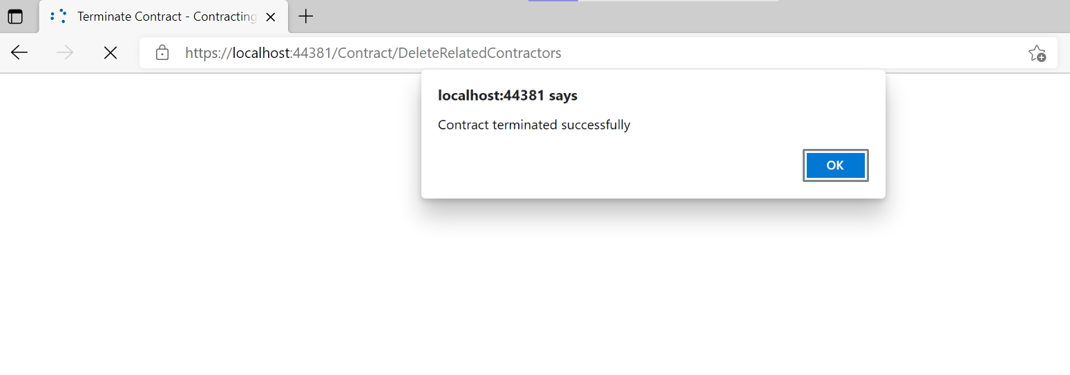

1. A contractor must be selected before clicking fetch related data. If not an error message will be displayed on screen.

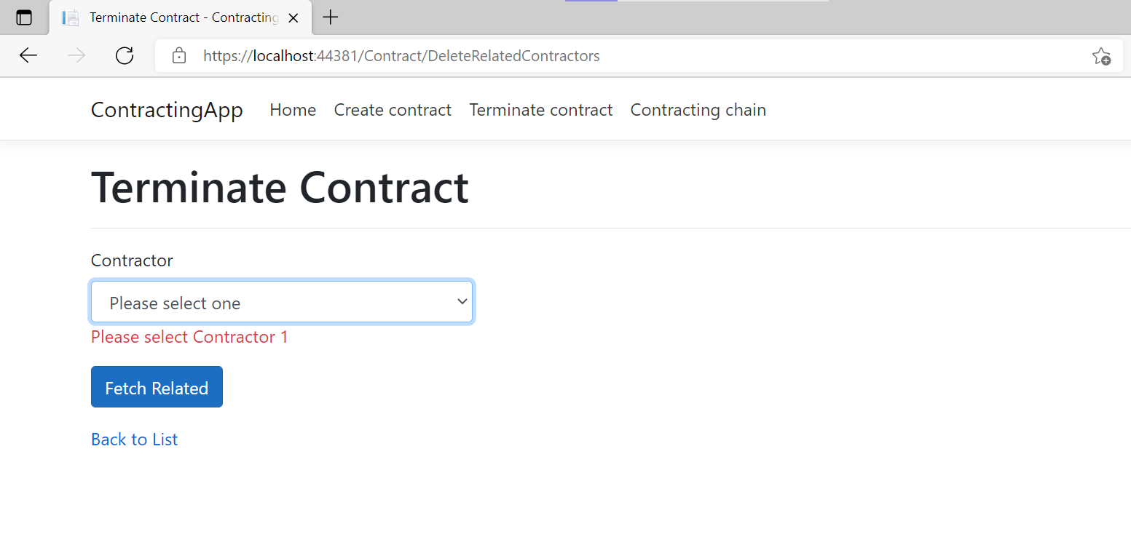

1. Contractor 2 must be selected before clicking Terminate button. If not an error message will be displayed

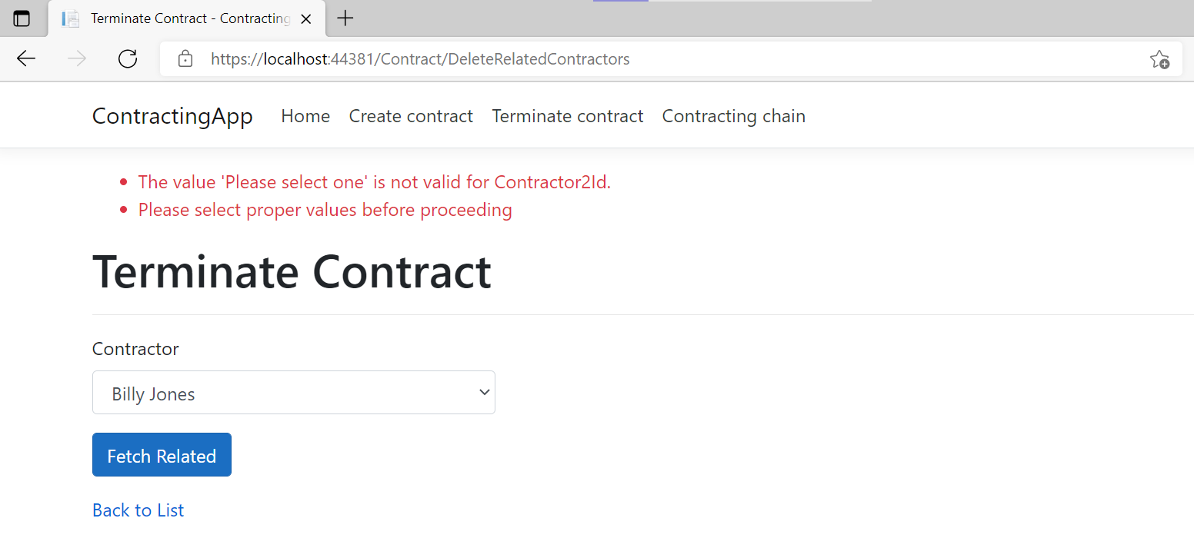

# Shortest Contracting Chain

1. This page finds the shortest link between two contractors. Select contractor 1 and contractor 2 from drop down and click Search. If there is a link it will be displayed below the Search button

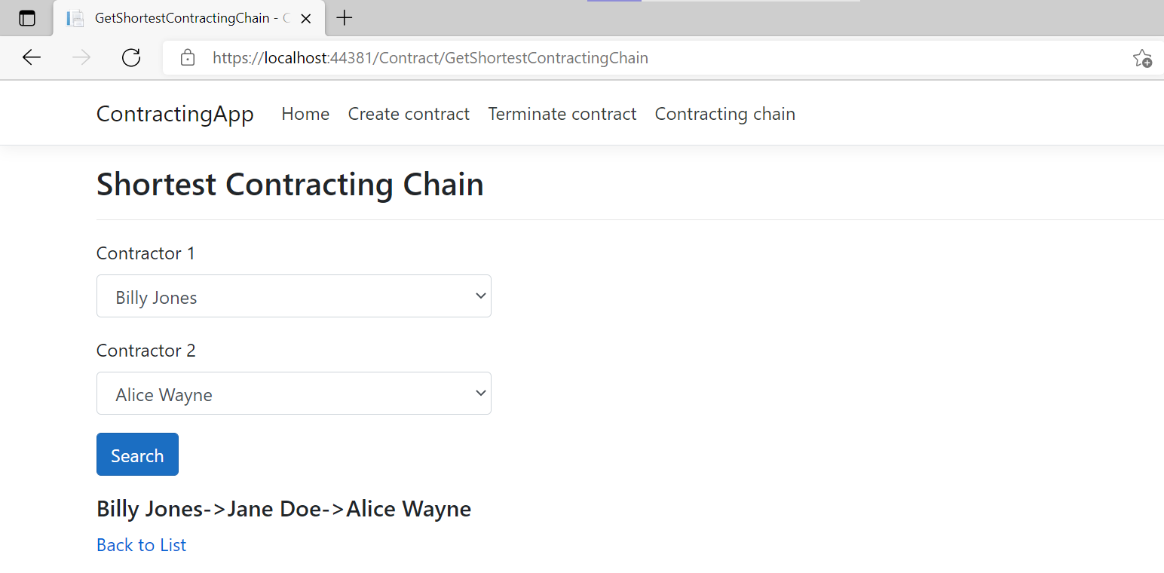

1. If no relation is found, a no relation found message will be displayed

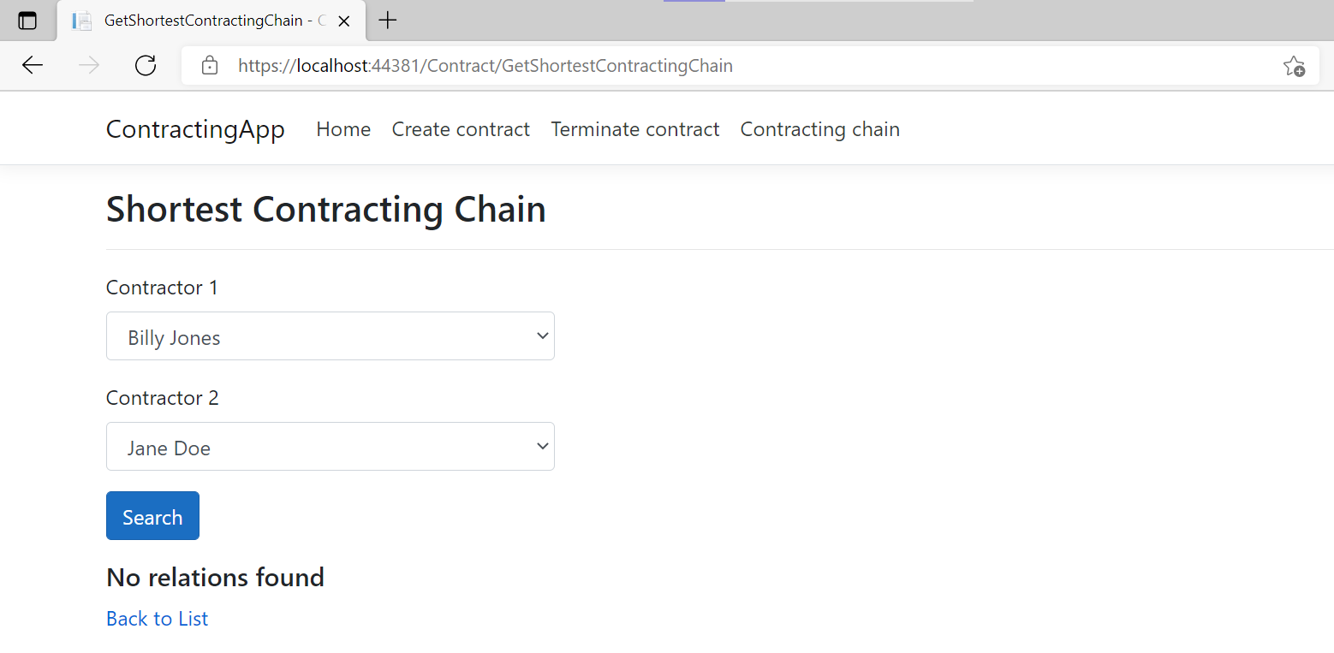

1. Shortest link cannot be displayed between same contractors. An error message will be displayed

